JAVA PROGRAMMING ASSIGNMENT – 9
Student Record File Manager
Unit 5 – File Handling in Java
Topics: File Class, FileInputStream, FileOutputStream & Exception Handling
Assessment Type: Individual Coding Assignment
Student Name | Sasanka Sekhar Kundu
Programming Language | Java
Assignment | Assignment 9 – Student Record File Manager

1. Objective
The objective of this assignment is to develop a Student Record File Manager in Java using file handling classes. The application creates a records directory and text file, allows student records to be written and appended, displays file information, reads the file byte by byte, and deletes the record file. Exception handling is used to handle file-related errors safely.

2. Problem Statement
The program provides a menu-driven interface for managing student records stored in a text file. It demonstrates the File class, FileOutputStream, FileInputStream, append mode, delete(), Scanner input, a loop, switch-case, and exception handling.

3. File and Directory Structure
Assignment 9 – Student Record File Manager/
├── StudentRecordFileManager.java
└── StudentRecords/
└── student.txt

4. Menu Options
- 1. Create Records Directory
- 2. Create Record File
- 3. Write Student Record
- 4. Display File Information
- 5. Read File Content
- 6. Append New Record
- 7. Delete Record File
- 8. Exit

5. Java Source Code
StudentRecordFileManager.java
import java.io.File;
import java.io.FileInputStream;
import java.io.FileOutputStream;
import java.io.IOException;
import java.util.Scanner;

public class StudentRecordFileManager {

static final String DIRECTORY_NAME = "StudentRecords";
static final String FILE_NAME = "student.txt";

public static void main(String[] args) {
Scanner scanner = new Scanner(System.in);
File directory = new File(DIRECTORY_NAME);
File recordFile = new File(directory, FILE_NAME);
int choice;

System.out.println("===== Student Record File Manager =====");

do {
System.out.println();
System.out.println("1. Create Records Directory");
System.out.println("2. Create Record File");
System.out.println("3. Write Student Record");
System.out.println("4. Display File Information");
System.out.println("5. Read File Content");
System.out.println("6. Append New Record");
System.out.println("7. Delete Record File");
System.out.println("8. Exit");
System.out.print("Enter your choice: ");

choice = scanner.nextInt();
scanner.nextLine();

switch (choice) {
case 1:
createDirectory(directory);
break;
case 2:
createRecordFile(directory, recordFile);
break;
case 3:
writeRecord(directory, recordFile, scanner);
break;
case 4:
displayFileInformation(recordFile);
break;
case 5:
readFileContent(recordFile);
break;
case 6:
appendRecord(directory, recordFile, scanner);
break;
case 7:
deleteRecordFile(recordFile);
break;
case 8:
System.out.println("Exiting Student Record File Manager.");
break;
default:
System.out.println("Invalid choice. Please enter 1 to 8.");
}
} while (choice != 8);

scanner.close();
}

public static void createDirectory(File directory) {
try {
if (!directory.exists()) {
if (directory.mkdir())
System.out.println("Directory created: " + directory.getPath());
else
System.out.println("Failed to create directory.");
} else {
System.out.println("Directory already exists: " + directory.getPath());
}
} catch (SecurityException e) {
System.out.println("Error creating directory: " + e.getMessage());
}
}

public static void createRecordFile(File directory, File recordFile) {
try {
if (!directory.exists() && !directory.mkdir()) {
System.out.println("Failed to create directory.");
return;
}

if (!recordFile.exists()) {
if (recordFile.createNewFile())
System.out.println("File created: " + recordFile.getPath());
else
System.out.println("Failed to create record file.");
} else {
System.out.println("Record file already exists: " + recordFile.getPath());
}
} catch (IOException | SecurityException e) {
System.out.println("Error creating file: " + e.getMessage());
}
}

public static void writeRecord(File directory, File recordFile, Scanner scanner) {
try {
if (!directory.exists()) directory.mkdir();
if (!recordFile.exists()) recordFile.createNewFile();

System.out.print("Enter student record: ");
String record = scanner.nextLine();

FileOutputStream outputStream = new FileOutputStream(recordFile);
outputStream.write((record + System.lineSeparator()).getBytes());
outputStream.close();

System.out.println("Record written successfully.");
} catch (IOException | SecurityException e) {
System.out.println("Error writing record: " + e.getMessage());
}
}

public static void displayFileInformation(File recordFile) {
try {
if (!recordFile.exists()) {
System.out.println("Record file does not exist.");
return;
}

System.out.println("===== File Information =====");
System.out.println("Name : " + recordFile.getName());
System.out.println("Path : " + recordFile.getPath());
System.out.println("Absolute Path : " + recordFile.getAbsolutePath());
System.out.println("Size : " + recordFile.length() + " bytes");
System.out.println("Is File : " + recordFile.isFile());
System.out.println("Is Directory : " + recordFile.isDirectory());
} catch (SecurityException e) {
System.out.println("Error displaying file information: " + e.getMessage());
}
}

public static void readFileContent(File recordFile) {
FileInputStream inputStream = null;

try {
if (!recordFile.exists()) {
System.out.println("Record file does not exist.");
return;
}

inputStream = new FileInputStream(recordFile);
System.out.println("===== File Content =====");

int data;
while ((data = inputStream.read()) != -1) {
System.out.print((char) data);
}
System.out.println();

} catch (IOException | SecurityException e) {
System.out.println("Error reading file: " + e.getMessage());
} finally {
try {
if (inputStream != null) inputStream.close();
} catch (IOException e) {
System.out.println("Error closing input stream: " + e.getMessage());
}
}
}

public static void appendRecord(File directory, File recordFile, Scanner scanner) {
try {
if (!directory.exists()) directory.mkdir();
if (!recordFile.exists()) recordFile.createNewFile();

System.out.print("Enter new student record: ");
String record = scanner.nextLine();

FileOutputStream outputStream = new FileOutputStream(recordFile, true);
outputStream.write((record + System.lineSeparator()).getBytes());
outputStream.close();

System.out.println("Record appended successfully.");
} catch (IOException | SecurityException e) {
System.out.println("Error appending record: " + e.getMessage());
}
}

public static void deleteRecordFile(File recordFile) {
try {
if (!recordFile.exists()) {
System.out.println("Record file does not exist.");
return;
}

if (recordFile.delete())
System.out.println("File deleted successfully.");
else
System.out.println("File deletion failed.");
} catch (SecurityException e) {
System.out.println("Error deleting file: " + e.getMessage());
}
}
}

6. Concepts Demonstrated
Concept | Implementation
File class | Represents the StudentRecords directory and student.txt file.
mkdir() | Creates the StudentRecords directory.
exists() | Checks whether the directory and record file exist.
createNewFile() | Creates student.txt when it does not exist.
FileOutputStream | Writes student records as byte data.
getBytes() | Converts the record String into bytes.
FileInputStream | Reads the file byte by byte.
read() and -1 | Reads until end-of-file is reached.
Append mode | new FileOutputStream(recordFile, true) preserves existing content.
File information | Uses getName(), getPath(), getAbsolutePath(), length(), isFile(), isDirectory().
delete() | Removes the record file and reports success or failure.
Exception handling | try-catch handles file/security errors and finally closes the input stream.
Loop and switch | do-while repeats the menu and switch selects each operation.
Scanner | Accepts menu choices and student record input.

7. Execution Evidence
The provided screenshot shows the Student Record File Manager running successfully in the VS Code terminal. The program writes a student record, displays the menu again, and exits when option 8 is selected. The VS Code Explorer also shows the StudentRecords directory and student.txt file.
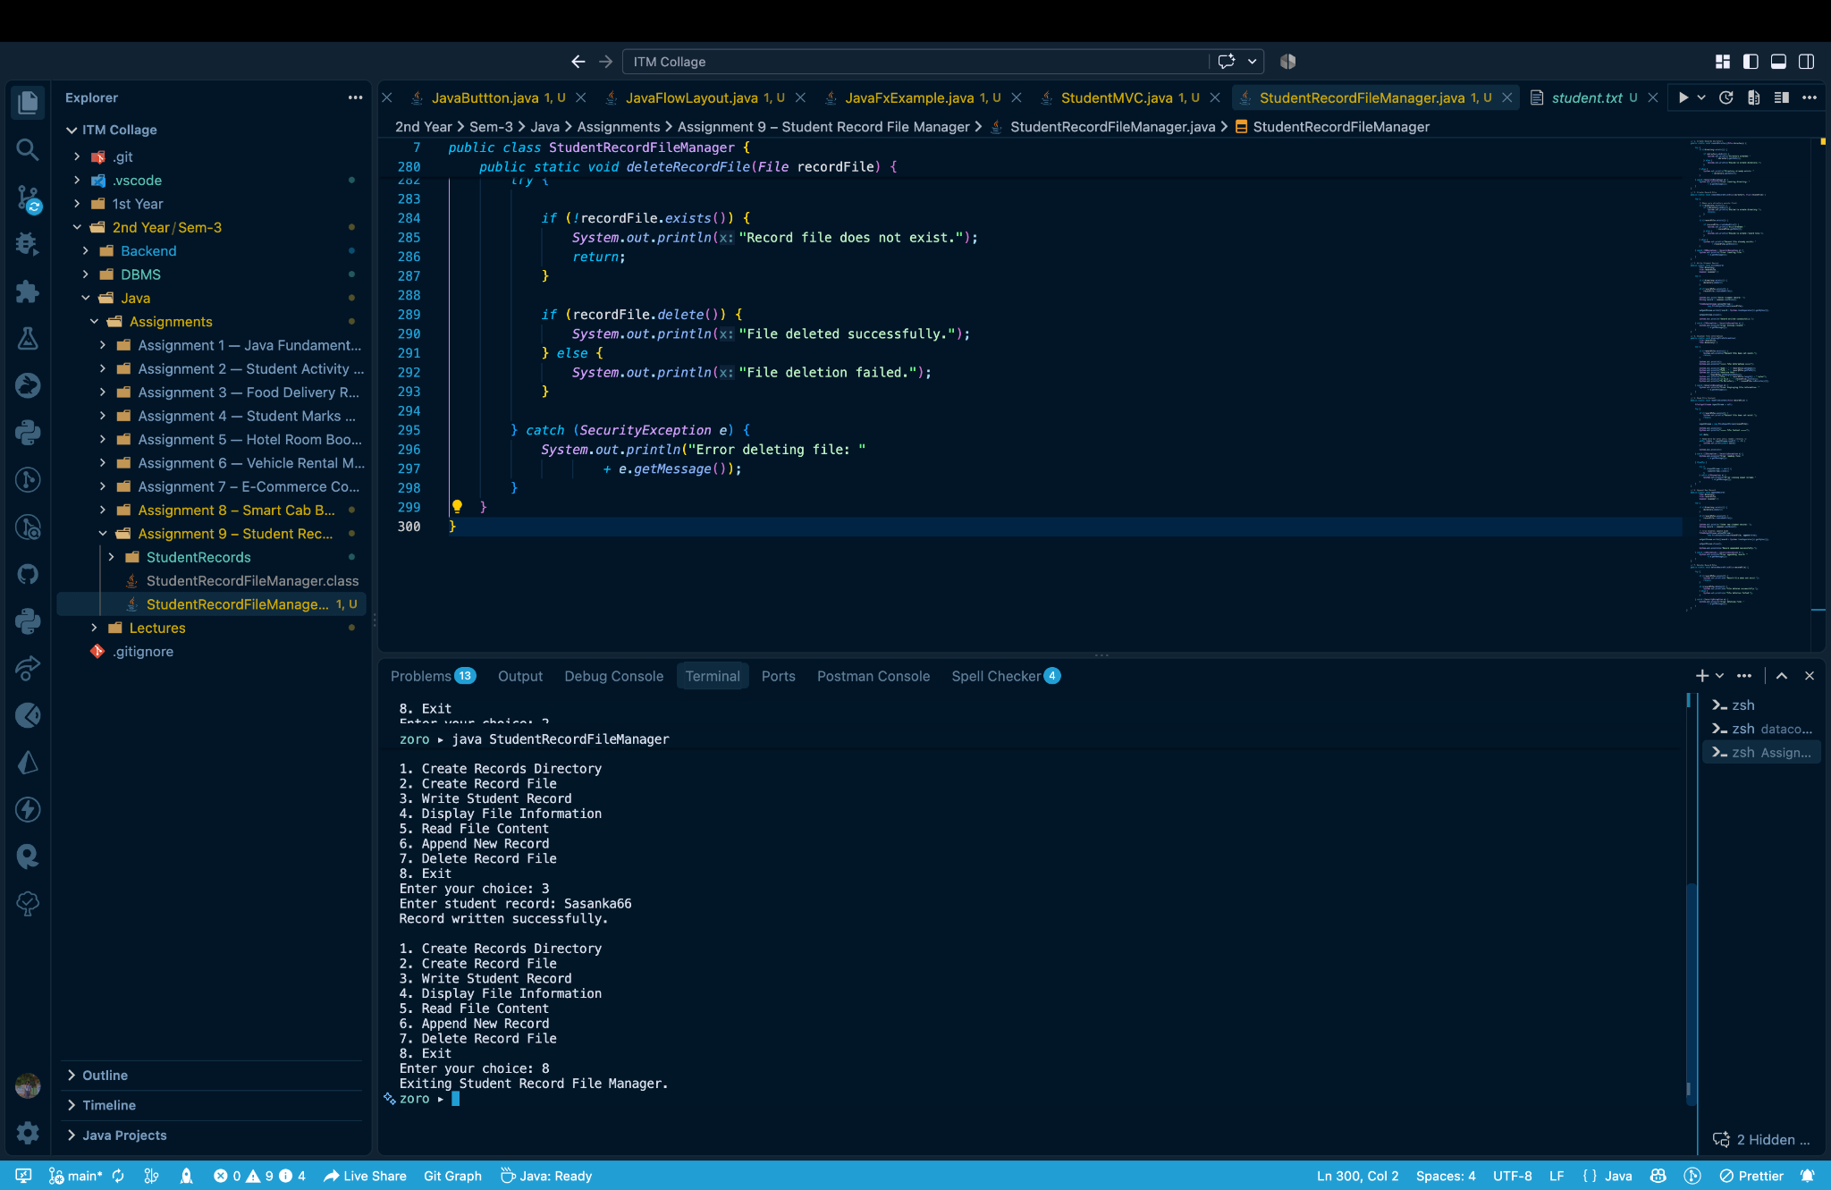
Figure 1: Student Record File Manager source code, generated StudentRecords directory/student.txt, and terminal execution.

8. Output Analysis
In the demonstrated execution, option 3 is selected and a student record is entered. The application reports “Record written successfully.” The menu is then displayed again, confirming that the loop and switch structure continue to operate. Option 8 exits the application cleanly.

9. Requirement Verification
Requirement | Status
StudentRecords directory using mkdir() | Implemented
exists() check before file creation | Implemented
student.txt using createNewFile() | Implemented
FileOutputStream write and getBytes() | Implemented
Required File information methods | Implemented
FileInputStream byte-by-byte reading until -1 | Implemented
FileOutputStream append mode with true | Implemented
delete() implementation | Implemented
Exception handling | Implemented
Repeated menu loop and switch | Implemented
Scanner input and confirmation/error messages | Implemented

10. Result
The Student Record File Manager was successfully implemented in Java. It provides menu-driven operations for creating the directory and file, writing and appending records, viewing file properties, reading content, deleting the record file, and exiting the application.

11. Conclusion
This assignment provided practical experience with Java file handling. The completed application demonstrates File, FileInputStream, FileOutputStream, append mode, delete(), Scanner, loops, switch statements, and exception handling.

12. Submission Checklist
☑ StudentRecordFileManager.java created.
☑ StudentRecords directory and student.txt used.
☑ Write and append operations implemented.
☑ File information and read operations implemented.
☑ Delete operation implemented.
☑ Exception handling implemented.
☑ Menu loop, switch, and Scanner implemented.
☑ Execution screenshot included.

